

Project work:
«Inventory management system»
Done by: Nurislam Kurmankul
Student of 11С
Assessed and checked by: Kosemova A.R
Computer science teacher

2025 – 2026 academic year

Content
1. Analysis 2
1.1 Introduction 3
1.2 Old system description 3
1.3 Old system’s flowchart 3
1.4 DFD Level 0 3
1.5 Client involvement 3
1.6 Data analysis 4
1.7 Alternative methods 5
1.8 Requirements 6
2. Design 6
2.1 Objectives 6
2.2 New system’s flowchart 7
2.3 DFD Level 1 7
2.4 ERD 7
2.5 Data dictionary 8
2.6 Input/output designs 8
2.7 Benefits 10
2.8 Limitations 10

1. Analysis

1.1 Introduction
The client, Joe’s Electronics, requires a system to enhance inventory management processes. Currently, much of the work is performed manually, which is time-consuming and prone to error. The proposed system aims to automatically generate a daily report summarizing products sold and the remaining stock levels. The system must be reliable, user-friendly, and efficient, reducing manual workload while supporting informed business decision-making.

1.2 Old system description
Joe’s Electronics currently relies on manual processes to track inventory. Employees record sales and update stock levels by hand, which is slow, inefficient, and often leads to mistakes. There is no automated way to generate daily summaries of sold products or remaining inventory, making it harder for the business to make timely and informed decisions.

1.3 Old system’s flowchart
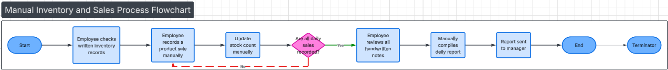

1.4 DFD Level 0
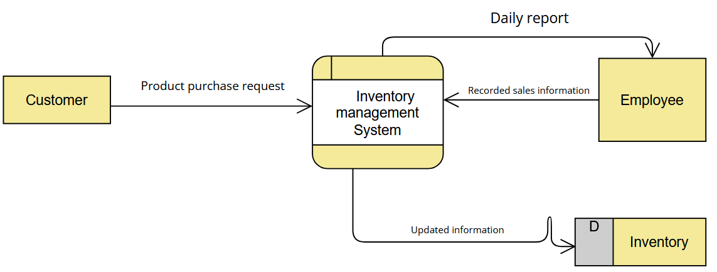

1.5 Client involvement
To determine a client’s needs an interview was held. The interview was recorded, and below provided some questions within the client’s answer
1. Question:
How do you currently record product sales and update inventory?
Customer Answer:
We do everything manually. Staff write down each sale and then update stock levels by hand at the end of the day.
2. Question:
What problems do you face with the current manual process?
Customer Answer:
It takes a lot of time and we often make mistakes, especially on busy days. Sometimes the stock numbers are inaccurate.
3. Question:
How do you track the remaining stock during the day?
Customer Answer:
We usually can’t see the exact stock in real time. Employees have to check the records or physically count items.
4. Question:
Do you prepare any reports for management? If yes, how?
Customer Answer:
Yes, we prepare a daily report manually by reviewing sales notes and inventory records. It’s slow and not always reliable.
5. Question:
What kind of improvements would you like from a new system?
Customer Answer:
We want the system to automatically update inventory after each sale and generate daily reports without manual work.
6. Question:
What are your expectations regarding ease of use and reliability?
Customer Answer:
The system should be simple for employees to use, reliable, and accurate so we can trust the data for business decisions.
Client’s needs:
• The system must automatically track products sold throughout the day.
• It must update stock levels in real time without manual calculations.
• Users should be able to view current inventory at any time.
• The system must automatically generate a daily summary report of sales and remaining stock.
• The interface should be simple and easy for employees to navigate.
• The system must minimize manual data entry and reduce errors.
• Reports should be accurate, easy to read, and ready for managers to use in decision-making.

1.6 Data analysis
What data exists
- Manual sales records (product name, quantity sold, date)
- Manual inventory logs (product name, stock quantity)
- Handwritten or basic spreadsheet daily reports
What data is needed
- Product information (ID, name, category)
- Sales transaction data (product ID, quantity sold, date, time)
- Current stock levels updated automatically
- Daily summary reports of sales and remaining inventory
Attributes
- Product: product ID, product name, category, unit price, stock quantity
- Sale: sale ID, product ID, quantity sold, date, time
- Report: report ID, report date, total products sold, remaining stock per product
Structure of data
- Data stored in structured tables
- Products linked to sales through product ID
- Inventory quantities updated based on sales transactions
- Reports generated from aggregated sales and inventory data

1.7 Alternative methods
Method 1: Manual Inventory Management (Current System)
Inventory and sales are recorded by employees using paper records or simple spreadsheets. Daily reports are prepared manually at the end of each day.
Advantages:
- No software cost
- Simple to understand
Disadvantages:
- Time-consuming
- High risk of human error
- No real-time inventory visibility
- Reports are slow and often inaccurate

Method 2: Automated Inventory Management System (Proposed System)
Sales and inventory are recorded automatically in a computerized system. Stock levels are updated in real time, and daily reports are generated automatically.
Advantages:
- Faster and more efficient
- Reduces human errors
- Real-time inventory tracking
- Automatic daily reports for management
Disadvantages:
- Initial setup cost
- Requires basic staff training

Criteria | Manual System | Automated System
Speed | Slow | Fast
Accuracy | Low | High
Reporting | Manual | Automatic
Reliability | Low | High

1.8 Requirements
User Requirements
- The system must allow employees to record sales easily.
- Stock levels must be updated automatically after each sale.
- Users should be able to view current inventory at any time.
- The system must generate a daily sales and inventory report automatically.
- The interface should be simple and user-friendly.
- Managers must be able to access accurate reports for decision-making.

2. Design

2.1 Objectives
The objectives of the new inventory management system are:
- To automate the recording of product sales.
- To update inventory levels in real time after each sale.
- To reduce human errors caused by manual data entry.
- To automatically generate accurate daily sales and inventory reports.
- To provide employees with quick access to current stock information.

2.2 New system’s flowchart
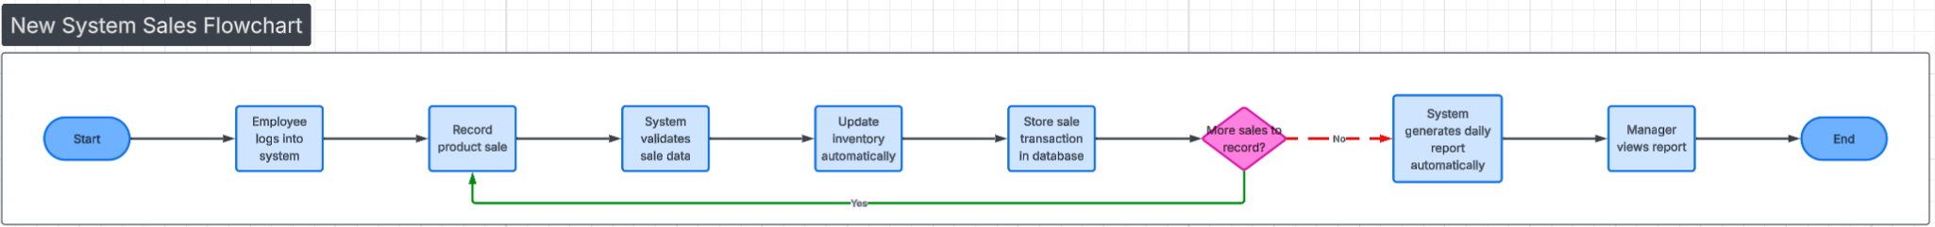

2.3 DFD Level 1
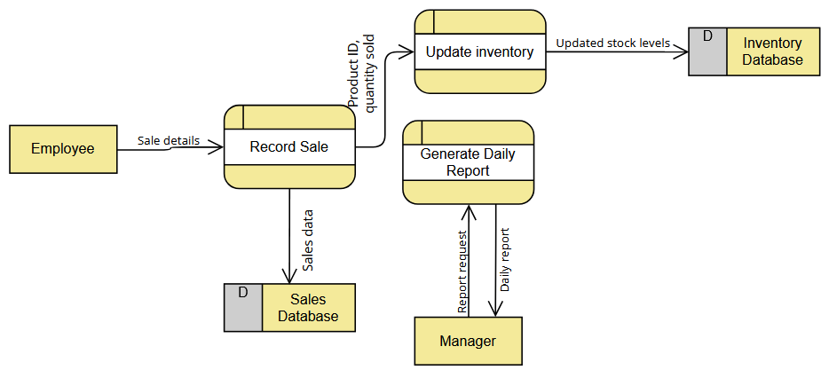

2.4 ERD
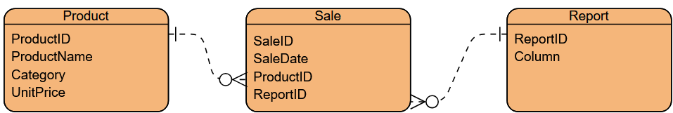

2.5 Data dictionary
Product Table
Field Name | Data Type | Size | Example | Description
ProductID | INT | 10 | 01 | Unique product identifier
ProductName | VARCHAR | 100 | Coca-cola | Name of the product
Category | VARCHAR | 50 | Soda | Product category
UnitPrice | DECIMAL | 10,2 | 10.24 | Price per unit
Sale table
Field Name | Data Type | Size | Example | Description
SaleID | INT | 10 | 01 | Unique sale identifier
SaleDate | DATE | 8 | 01/12/2025 | Date of sale
ProductID | INT | 10 | 01 | References Product
ReportID | INT | 10 | 01 | References Report
Report Table
Field Name | Data Type | Size | Example | Description
ReportID | INT | 10 | 01 | Unique report identifier
ReportDate | DATE | 8 | 01/12/2025 | Date report is generated

2.6 Input/output designs
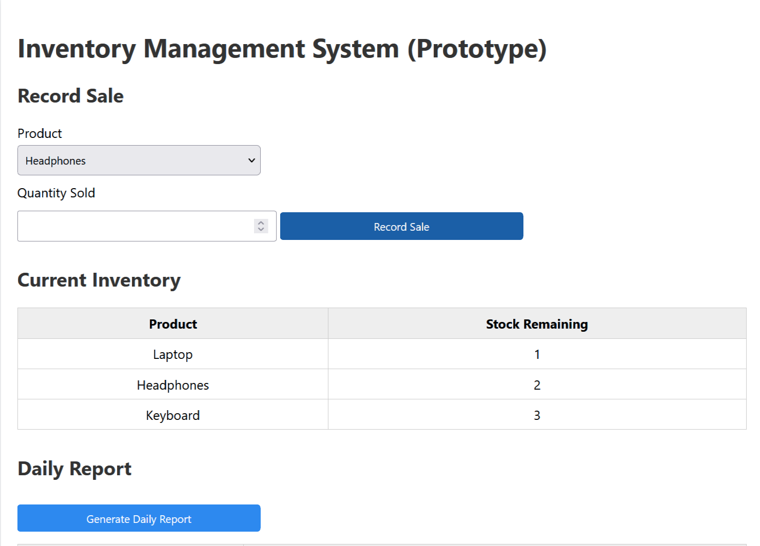
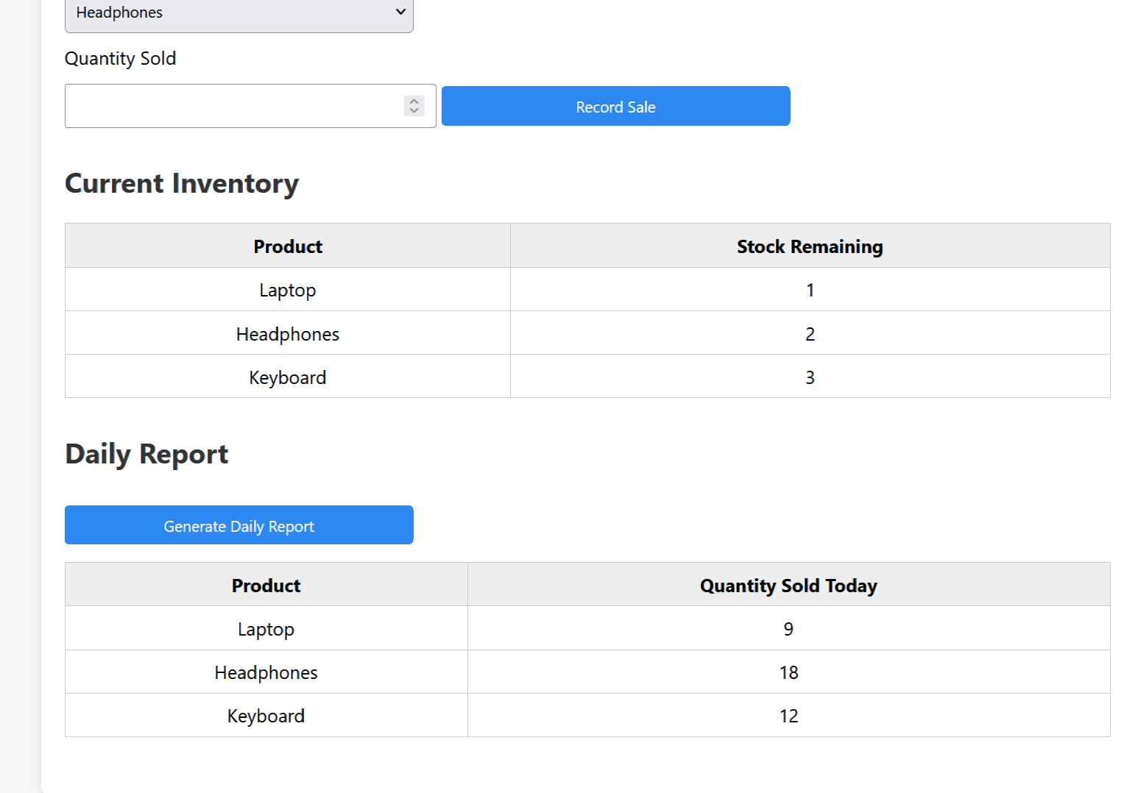

2.7 Benefits
The new inventory management system provides several advantages:
- Reduces manual work by automating sales recording and inventory updates.
- Minimizes human errors caused by handwritten records and calculations.
- Provides real-time access to current stock levels.
- Automatically generates accurate daily sales and inventory reports.
- Saves time for employees and managers.
- Improves decision-making by providing reliable and up-to-date data.
- Increases overall efficiency and productivity of the business.

2.8 Limitations
Despite its advantages, the system has some limitations:
- Requires initial setup time and cost for development and deployment.
- Employees may need training to use the new system effectively.
- The system depends on hardware and electricity; system failure may temporarily stop operations.
- Data accuracy still depends on correct input by employees.
- The prototype does not include advanced features such as user authentication or data backups.
- System maintenance and updates may be required over time.

